SCUBA-2 Block Specification
reply_translator

Table of Contents

1. Block Overview 3
1.1 Block Location and Block Interface Within System 3
1.2 Overview of reply structure and data structure 3
1.3 Overview of command procedures 5
1.3.1 ‘GO’ Command (start_application) 5
1.3.2 ‘RS’ Command (reset) 5
1.3.3 ‘RB’ Command (read_block memory) 5
1.3.4 ‘WB’ Command (write_block memory) 5
1.3.5 ‘ST’ Command (stop_application) 6
1.4 Overview of block 6
1.4.1 Block operations 6
1.5 Block Dataflow 8
2. Block Interfaces 10
2.1 Interface Signal Description 10
2.2 Interface Protocol and Timing 12
3. Files of the Block 14
3.1 Source Code 14
3.1.1 reply_translator.vhd 14
3.2 Header Code 14
3.2.1 issue_reply_pack.vhd 14

Block Overview

This main function of this block is to construct fibre command replies and write them as a byte stream to the transmit fifo fibre_tx_fifo. It also handles the writing of frames of data to the transmit fifo.

Block Location and Block Interface Within System
This block is located on the clock card FPGA. It interfaces with the following blocks on the clock card:
- fibre_tx
- reply_queue
- cmd_translator

Overview of reply structure and data structure
This section provides a brief overview of the command reply structure and data structure.
There are five fibre commands namely ‘read_block memory’, ‘write_block memory’, ‘start_application’, ‘stop_application’, and ‘reset’. The structure of their replies to the host PC is shown in Table 1 (with the exception of a successful read_block memory command – which is discussed later).

(2X32 bits)  Preamble | (32 bit) | (32 bit) | (32 bit) | 2* (32 bit) |  | (32 bit)
0xA5A5A5A5  0x5A5A5A5A | “ RP”  0x20205250 | Packet size  (4) | Reply | Reply arguments |  | Checksum
Header1/2 | Header3 | header4 | Word1 | Word2 | Word3 | Word4

Table 1: Command Reply Structure (not read_memory block)

As shown there are four 32-bit header words followed by four 32-bit reply words. The packet size gives the number of 32-bit words in the packet (in this case 4). The header words are used by the PCI interface and are not used by the RTL software.
The actual reply words are detailed in the tables below. Table 2 reveal the replies to successfully executed commands, while Table 3 reveals the replies when an error has occurred.
 | Success reply
 | Word 1 | Word2 | Word 3 | Word 4
Start_application | “GOOK“( 0x474F4F4B) | CardId+ ParaId | 0x0 | Checksum
Stop_application | “STOK”( 0x53544F4B) | CardId+ ParaId | 0x0 | Checksum
Reset | “RSOK” ( 0x52534F4B) | CardId+ ParaId | 0x0 | Checksum
Write_Block memory | “WBOK”( 0x57424F4B) | CardId+ ParaId | 0x0 | Checksum

Table 2: Replies to successfully executed fibre commands

 | Error reply
 | Word 1 | Word2 | Word 3 | Word 4
Start_application | “GO ER”(0x474F4552) | CardId+ ParaId | Error Number | Checksum
Stop_application | “STER”(0x53544552) | CardId+ ParaId | Error Number | Checksum
Reset | “RSER”(0x52534552) | CardId+ ParaId | Error Number | Checksum
Write_Block memory | “WBER”( 0x57424552) | CardId+ ParaId | Error Number | Checksum
Read_Block memory | “RBER” (0x52424552) | CardId+ParaId | Error number | Checksum

Table 3: Replies to fibre commands in error

As mentioned above, the reply to a successful read_block memory command takes a slightly different format. This is because the reply includes a block of N data words read from memory (where N is in the range 1 → 58). The reply structure is revealed in Table 4.

 | Success reply
 | word 1 | word 2 | word 3 to word N+2 | word N + 3
Read_Block memory | “RBOK” ( 0x52424F4B) | CardId+ParaId | N Data values | Checksum

Table 4: Reply to successful executed read_block memory command

The firmware must generate a standard format reply upon the completion of the command, with the exceptions of ‘reset’ and ‘start_application’, which generate replies before execution. Such standard replies indicate the success or failure of the command.

When a ‘start_application’ command is received by the firmware it must generate a reply to the command then execute the command. Furthermore, the execution of a ‘start_application’ command must always generate data. This data might be a frame/N frames of status information or may be a frame/N frames of pixel data. All data frame packets take the format shown it Table 5.

(2X32 bit)  Preamble | (32 bit) | (32 bit) | (N x 32 bits)  Frame block |  |  | (32bit)
0xA5A5A5A5  0x5A5A5A5A | “ DA”  0x20204441 | Packet size | Frame status | … | … | Checksum
Header1/2 | Header3 | Header4 | Word1 | Word2 | … | WordM

Table 5: Data Frame Packet Format
As shown in Table 4, there are 4 packet header words (used by the PCI interface) and M frame words. The first frame word is a status word used by the RTL software.

Overview of command procedures
This section describes the chain of events for each of the 5 permitted commands.

‘GO’ Command (start_application)

- When cmd_translator receives a GO command it notifies reply_translator.
- Reply_translator immediately issues a reply to the GO command (this is to acknowledge the receipt of the GO command to the RTL software, which in turn frees up the RTL camera task to issue a ST command if required). Note that the last word of the reply is the reply packet checksum.
- Meanwhile, the cmd_translator begins issuing maro_ops to run the application instigated by the GO command. The application must generate at least one data packet.
- When a data packet is ready reply_queue informs reply_translator.
- Reply_translator subsequently writes the appropriate data packet header to the transmit FIFO.
- Reply_translator then reads the data packet word by word from reply_queue, splitting each word up into four bytes and writing it little endian to the transmit FIFO.
- Finally reply_queue writes the data packet checksum to the transmit FIFO.
- Reply_translator then informs reply_queue that the data packet has been written to the transmit FIFO.

Steps 4 through to 8 are repeated for every data packet generated by the running application.

‘RS’ Command (reset)

- When cmd_translator receives a RS command it notifies reply_translator.
- Reply_translator immediately issues a reply to the RS command (reply packet written to the transmit FIFO).
- Meanwhile cmd_translator beings issuing the appropriate macro_ops to perform the reset.

‘RB’ Command (read_block memory)

- When cmd_translator receives a RB command it notifies reply_translator.
- Reply_translator registers the command code, parameter id, and card id to be used in the reply packet on completion of the command.
- Meanwhile, the cmd_translator issues a maro_op to execute the command.
- Once completed (successfully or in error) reply_queue informs reply_translator.
- Reply_translator writes the appropriate reply packet header, and reply words 1 and 2 to the transmit FIFO. Each word is split up into four bytes and written little endian.
- Reply_tranlator then reads the read_block words (word 3 → N+2) from reply_queue. Each word is split up into four bytes and written little endian to the transmit FIFO.
- Reply_translator then writes the reply packet checksum to the transmit FIFO.
- Reply_translator then informs reply_queue that the reply packet transmission has been completed.

‘WB’ Command (write_block memory)

- When cmd_translator receives a WB command it notifies reply_translator.
- Reply_translator registers the command code, parameter id, and card id to be used in the reply packet on completion of the command.
- Meanwhile, the cmd_translator issues a maro_op to execute the command.
- Once completed (successfully or in error) reply_queue informs reply_translator.
- Reply_translator writes the appropriate reply packet header, and reply words 1 and 2 to the transmit FIFO. Each word is split up into four bytes and written little endian.
- Reply_tranlator then reads reply word 3 from reply_queue, splits it into four bytes and writes it little endian to the transmit FIFO.
- Reply_translator then writes the reply packet checksum to the transmit FIFO.
- Reply_translator then informs reply_queue that the reply packet transmission has been completed.

‘ST’ Command (stop_application)
Note: this command is only ever issued while a data generating application is running.

- When cmd_translator receives a ST command it notifies reply_translator.
- Reply_translator registers the command code, parameter id, and card id to be used in the reply packet on completion of the command.
- Meanwhile, the cmd_translator issues a maro_op to execute the command, i.e. stop the data generating application.
- The command propagates through the MCE.
- The next data packet generated by the running application should be flagged as the ‘last frame’, after which no more data packets should be generated (i.e. application terminated).
- Reply_queue continues to inform reply_translator each time there is a data packet to be transmitted. The next one should be the last frame, but might not be depending on when the ST command is received in the readout cycle.
- Once the last frame data packet has been packaged up and written to the transmit FIFO by cmd_translator, reply_queue informs reply_translator to send a reply packet.
- Reply_translator writes the appropriate reply packet header, and reply words 1 and 2 to the transmit FIFO. Each word is split up into four bytes and written little endian.
- Reply_tranlator then reads reply word 3 from reply_queue, splits it into four bytes and writes it little endian to the transmit FIFO.
- Reply_translator then writes the reply packet checksum to the transmit FIFO.
- Reply_translator then informs reply_queue that the reply packet transmission has been completed.

Note that for the ST, WB, and RB command replies, reply_queue must inform reply_translator of the number of reply words to be retrieved from it. For ST and WB this will always be one word (Word 3 of the reply – see Tables 2 & 3). For the RB command this will be one word (error number) if the command was unsuccessfully completed, or N words for a successfully completed command. Where N is the number of valid words in the block read to be returned to the linux PC.

Similarly, for all data packets, reply_queue must inform reply_translator of the number of words in the data frame. reply_translator then retrieves these words from reply_queue.

Overview of block
A command successfully received by fibre_rx is convereted into one or more ‘macro_operation’ (m_op) commands by ‘cmd_translator’. reply_queue informs reply_translator when a m_op has been completed. reply_translator subsequently packages up a reply or data packet and writes it to fibre_tx as a byte stream to be transmitted to the linux PC. In addition, reply_queue informs reply_translator when a locally generated (i.e. generated by the MCE) macro_op is completed. Currently, reply_translator does nothing with this information.

Block operations
Reply_translator must perform the following operations (Refer to the Figures 1 and 2 of Section 1.4)

- Fibre checksum error replies: in the event of a fibre command being received with a checksum error, the block fibre_rx will inform cmd_translator, which in turn informs reply_translator. An error reply is subsequently packaged up and written to the transmit FIFO (fibre_tx_fifo).
- Start_application and Reset Replies: In the event of a ‘start_application’, or ‘reset’ command being successfully received, fibre_rx will inform cmd_translator, which in turn informs reply_translator. A success reply is then packaged up and written to the transmit FIFO (fibre_tx_fifo). This reply informs the high level software that the command has been successfully received.
- Other command replies: when a ‘write_block memory’, ‘read_block memory’ or ‘stop_application’ command is successfully received fibre_rx informs cmd_translator, which in turn informs reply_translator. Reply_translator registers the command code, parameter id, and card id for use in the reply packet. Once the command is completed reply_queue informs reply_translator. It does this by asserting m_op_done_i high and also setting reply_nData high to indicate that it is a reply that is to be transmitted and not a frame of data (this is required so that the correct header is prefixed to the packet). Reply_queue also informs reply_translator if the command was completed successfully or in error (m_op_ok_nEr_i = ‘1’ for a successfully completed command and m_op_ok_nEr_i = ‘0’ for a command completed in error). reply_queue must also provide word 3 of the ‘write_block memory’ and ‘stop_application’ replies (see tables 2 and 3), and words 3 → N+2 of the ‘read_block memory’ command (see table 4). These words are provided on ‘fibre_word_i’ each time ‘fibre_word_req_o’ is asserted high. reply_queue must inform reply_translator of the number of words to be clocked out of ‘fibre_word_i’, by writing an appropriate value to ‘num_fibre_words’. This value should be available for reply_translator to read when m_op_done_i is asserted.
- Data Frame Packets: reply_queue informs reply_translator when there is a frame of data to be transmitted to the host. It does this by asserting m_op_done_i high and reply_nData low. The ‘frame’ of data (which could be a frame of status information or pixel data) is clocked out word by word on ‘fibre_word_i’ each time ‘fibre_word_req_o’ is asserted high. reply_queue must inform reply_translator of the size of the frame (i.e. number of 32-bit words). It does this by writing the appropriate value to ‘num_fibre_words_i’, which must be available for reply_translator to read when ‘m_op_done_i’ is asserted high.
- Checksum Calculator: the reply_translator also includes a checksum calculator. A checksum word is appended to all packets written to the transmit FIFO (fibre_tx_fifo). As previously mentioned the checksum is a 32bit sequential XOR.

Note that when reply_queue informs reply_translator that a macro op has been completed, it must hold the following inputs valid until m_op_ack_o is asserted:
- m_op_done_i
- m_op_ok_nEr_i
- reply_nData_i
- num_fibre_words_i
m_op_ack_o is asserted once the reply packet has been processed and written to the transmit FIFO.

Block Dataflow

to fibre
from fibre
fibre_rx
…
frame #
macro seq#
macro instr
cmd_translator
cmd_queue
macro seq#
μ seq#
μ instr
0
rp→
ip→
rp→
ip→
rp→
ip→
1
2
bus_tx (LVDS)
bus_rx (LVDS)
bus_rx (LVDS)
from AC
from BC
from CC
reply_queue
reply_translator
fibre_tx
1
3
2
8
4
6
7
:
:
ack
Figure 1 Details of the Issue/Reply Block

5

Figure 2: Data flow for reply_translator

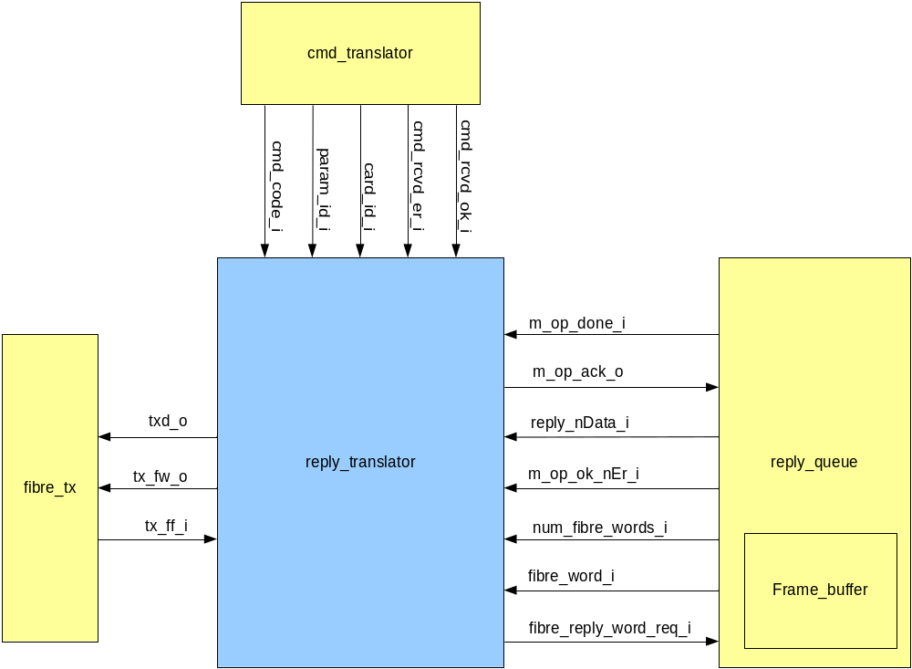

Block Interfaces

Interface Signal Description
- Interface Signals
Signal | Description | Direction
Global Signals
clk_i | Global clock signal | in
rst_i | Global asynchronous active-high reset | in
Signals to/from fibre_tx
txd_o  (7..0) | Byte wide data input to the transmit FIFO fibre_tx_fifo. All replies or data frames are written as a byte stream to the fifo. | out
tx_fw_o | When this signal is asserted high txd_o is written to the FIFO fibre_tx_fifo. | out
tx_ff_i | Asserted high when fibre_tx_fifo is full. If asserted then reply_translator will not write any data to the FIFO. | in
Signals to/from cmd_translator
cmd_rcvd_er_i | This is asserted high by cmd_translator when a fibre command is received with a checksum error. When this occurs reply_translator must prepare an appropriate error reply and write it to the transmit FIFO. | in
cmd_rcvd_ok_i | This is asserted high by cmd_translator when a fibre command is successfully received. On this assertion reply_translator registers the inputs cmd_code_i, param_id_i and card_id_i, and in the case of a start_application or reset command transmits a success reply. | in
cmd_code_i  (15..0) | This is the fibre command code word. It is returned to the RTL PC in the reply packet. It is also used to determine if the received command was a start_application or reset command. It must be valid when cmd_rcvd_ok_i or cmd_rcvd_er_i is asserted high. | in
param_id_i  (15..0) | This is the fibre command parameter ID word. It is returned to the RTL PC in the reply packet. It must be valid when cmd_rcvd_ok_i or cmd_rcvd_er_i is asserted high. | in
card_id_i  (15..0) | This is the fibre command card ID word. It is returned to the RTL PC in the reply packet. It must be valid when cmd_rcvd_ok_i or cmd_rcvd_er_i is asserted high. | in
Signals to/from
reply_queue
m_op_done_i | m_op_done_i is asserted high by reply_queue whenever it wants to inform reply_translator that a macro operation has been completed. Subsequently, either a fibre command reply, or a frame of data is packaged up and written to the transmit FIFO. The value of reply_nData determines if it is a reply or a frame of data that is to be transmitted. | in
m_op_ack_o | This is used reply_translator to acknowledge the receipt of m_op_done_i to reply_queue. It is asserted once the packet has been processed and written to the transmit FIFO. | out
reply_nData_i | When m_op_done_i is asserted the value of reply_nData_i indicates to reply_translator if it is a command reply (reply_nData_i = ‘1’) or a frame of data (reply_nData_i = ‘0’) that should be written to the transmit FIFO. It should hold valid until m_op_ack_o is asserted. | in
m_op_ok_nEr_i | The value of this signal determines if the m_op command was completed successfully or in error. A logic high indicates that the reply should be a successful reply, and a logic low indicates that the reply should be an error reply. It should hold valid until m_op_ack_o is asserted. | in
fibre_word_i  (31..0) | This port is used by reply_queue to transfer fibre command reply words or data frame words to reply_translator. Word 3 of the reply packet is provided on fibre_word_i for the ‘write_block memory’ and ‘stop_application’ command replies. Words 3~63 of the ‘read_block memory’ command are provided on fibre_word_i. All frame data words are provided on fibre_word_i.  Words are made available on fibre_word_i when reply_translator requests them. It does this (for each word) by asserting fibre_word_req_o high. | in
fibre_word_req_i | This is asserted high to request reply_queue to make a fibre packet word available on fibre_word_i. | in
num_fibre_words_i  (31..0) | This value indicates the number of words that reply_queue has to clock out of fibre_word_i. This will always be equivalent to 1 for write_block memory, and stop_application replies, and 62 for read_block_memory commands. For frame data is will be equivalent to the size of the data frame (in 32bit words). | in

Interface Protocol and Timing

High-Level Description

State Machine Description

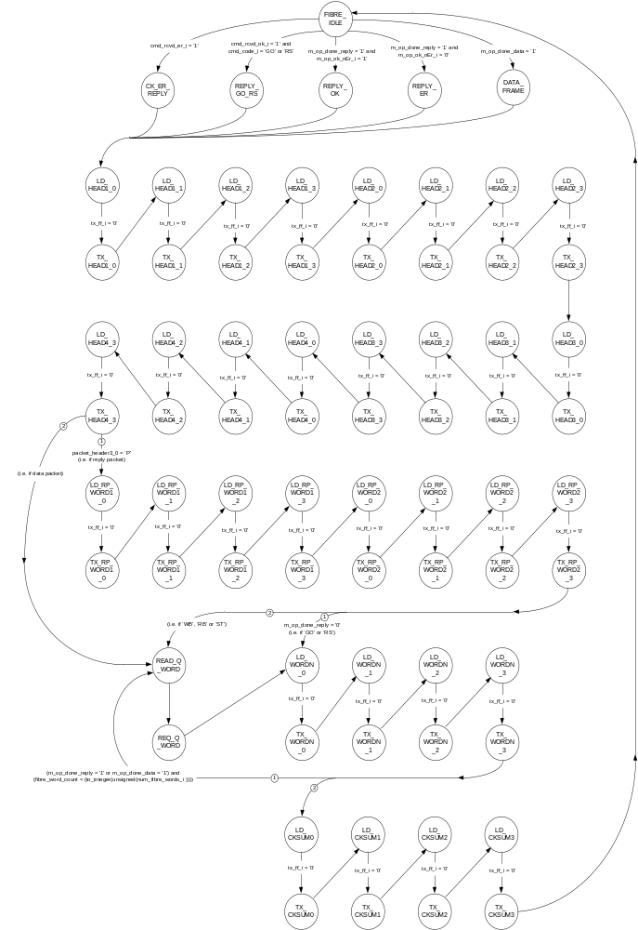
The main core of reply_translator is a Finite State Machine (FSM), which packages up reply and data packets and writes them to the transmit FIFO fibre_tx_fifo. The state transition diagram for this FSM is shown above.

Files of the Block

Source Code

reply_translator.vhd

Header Code

issue_reply_pack.vhd

